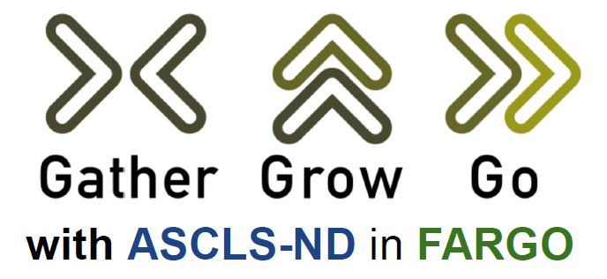

Monday, April 20th & Tuesday, April 21st

Educational Symposium Registration Form

Join us to network with laboratory professionals from around the region. P.A.C.E. credits will be awarded for each educational session attended up to 10 total credits!

REGISTRATION

Directions:
- Registration & payment can be completed online (with minimal service charge) through the ASCLS-ND website: www.asclsnd.org OR by mail using information provided at the end of this form.
- Registrations must be postmarked by April 10, 2026. Registrations received after this date will be charged a $20 late fee.

PRICING

 | Full Meeting  (Both Mon & Tues) | Half Meeting  (Mon or Tues only) | Student Admission
Price | $155.00 | $85.00 | $25.00

ACCOMODATIONS

Conference attendees can get a room at the Holiday Inn Fargo at a price of $120.00 per night. Reservations must be made by phone. Simply mention that you are part of the “American Society for Clinical Laboratory Science conference” to be eligible for the group price (subject to availability - we encourage you to make your reservations early).

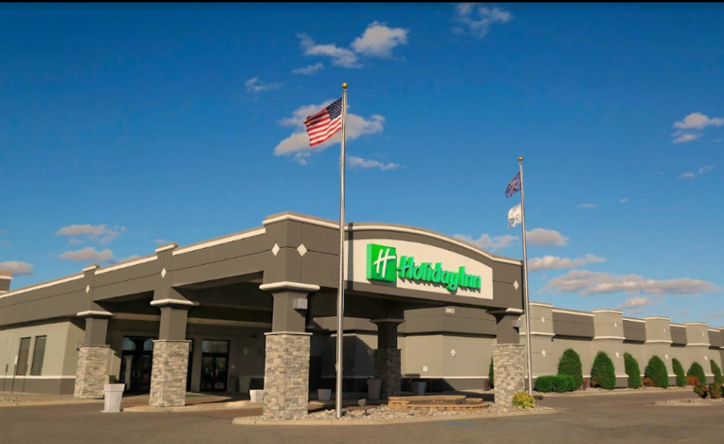
Holiday Inn Fargo
3803 13th Ave S
Fargo, ND 58103
Phone: 701-282-2700

SCHEDULE

Monday, April 20th, 2026
Time | Activity
11:00-12:20pm | ASCLS-ND Board Meeting (open to ASCLS-ND Board Members only)
12:30-1:20pm | Session 1 (Opening Keynote)
1:30-2:20pm | Session 2
2:20-2:50pm | SNACK & HOTEL CHECK-IN BREAK
2:50-3:40pm | Session 3
3:45-4:35pm | Session 4
4:45-5:35pm | Session 5
5:30-8:30pm | Vendor Social & Hors D'oeurvres
Tuesday, April 21st, 2026
Time | Activity
7:30 - 8:50am | Session 6 (Opening Keynote) & BREAKFAST
9:00-9:50am | Session 7
10:00-10:50am | Session 8
11:00-11:50am | Session 9
Noon-1:20pm | LUNCH & ASCLS-ND Business Meeting (all attendees encouraged to attend)
1:30-2:20pm | Session 8 (Closing Keynote)

---------------------------------------------------MAIL-IN REGISTRATION -------------------------------------------------------

Directions: After filling in all the information below, detach this portion of the registration form. Then, please mail both this portion of the form and a check payable to “ASCLS-ND” to:

Jessica Fry
711 N 28th St
Bismarck, ND

Your Information:

Name: ________________________________________________ Member ID #: ________________________

Street Address: __________________________________________

City: ______________________ State: ________________ Zip: __________________

Facility: ________________________________________________________________________________________

E-mail: _________________________________________________________________________________________
(required for registration invoice & confirmation and/or follow-up communication, if needed)

I have a food allergy YES/NO: _______ If yes, please describe: ____________________________________________

I would like to volunteer as a session moderator – YES/NO: _______

Registration Fee: ______ Late Fee (after 4/10/2026): ________ Total Fee Submitted: ___________

