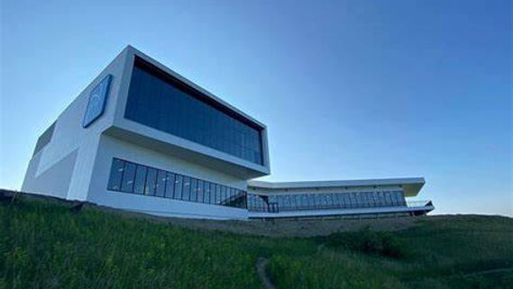

“Spring Symposium”
Bismarck, ND

EXHIBITOR REGISTRATION FORM

American Society for Clinical Laboratory Science - North Dakota

Supporting Sponsors:
When:
April 25th, 2024 6:00 pm – 9:00 pm: Vendor and Science Gallery Social
April 26th, 2024: Educational Sessions

Where:
Gateway to Science Center
1600 Canary Ave, Bismarck, ND 58501, USA
(701) 258-1975 ● http://www.gatewaytoscience.org

Accommodations:
Hampton Inn and Suites Bismarck Northwest
2020 Schafer St., Bismarck, ND 58501, USA
(701) 751-5656 ● http://www.hilton.com

From Lab to Life: Enhancing Patient Care

Join us for networking with Lab Professionals from all over the region. This is an awesome way to learn about potential professional opportunities and earn CEUs.

Meet new friends just like you! #talknerdie

Let’s discuss the issues that plague our field. #burnout #staffshortages

We are stronger as a profession by working together. Learn about how you can become involved in ASCLS-ND.

How To Register and Submit Payment:
 | Online (preferred) | Other
Complete the form | https://www.asclsnd.org | Email: Jessica Fry  asclsnd@gmail.com
Payment | https://www.asclsnd.org | Check payable to: ASCLS-ND  Mail check to: Jessica Fry  711 N. 28th St. Bismarck ND58501
W-9 #’s/Form: available upon request
THANK YOU FOR YOUR CONTINUED SUPPORT!!!

REGISTRATION INFORMATION
Complete & submit registration form and payment.

Pre-registration is required.
Registrations must be postmarked by April 10, 2024
Late fee of $20 applies after April 10, 2024.

Please enter information in this typeable document:

Company Name:
Contact name:
Sales Person(s) Attending:
(list all as name badges will be required)
Address:

City, State, Zip:

E-mail:
Phone:
Fax:

Instruction: Indicate registration level (type “X”) and additional meeting support below:
REGISTRATION DEADLINE IS APRIL 10th, 2024

 | Single exhibit booth space (approx. area-8 x 10 ft; 6’ x 30’’ table, 2 chairs) |  |  |  | $500
 | Please checkmark if electrical connection is needed for your display |  |  |  | N/A
 | Please checkmark if you will require a tablecloth - $7.00/table

The facility has an area to park demo trucks – please indicate if you will have one: YES / NO

Please note: the price of exhibit is for booth set up and up to 2 attendees (for food count) If more attendees are required, please add $10 per person

Number of extra attendees____________ x $10

 | Additional Support: Our Company would like to provide additional support for:
 | Provide a speaker for a workshop: |  | Name:
 | Sponsor the expense of a workshop speaker: |  | $ Amount:
 | Sponsor or help sponsor a break |  | $ Amount:
 | Sponsor Other (please indicate):

Meeting Questions: | Jessica Fry (E) asclsnd@gmail.com

EXHIBITOR FEE:
REGISTRATION AMOUNT (from above) | $
EXTRA ATTENDEE(S) AMOUNT | $
ADDITIONAL SUPPORT AMOUNT | $
$20 LATE FEE (if applicable) | $
MANUAL PROCESSING SERVICE FEE | $ | 15.00
TOTAL: | $

